團隊歷史及介紹
兒童和青年民俗舞蹈團KORNIČKA於1999年秋天成立於特倫欽(Trenčín)地區。
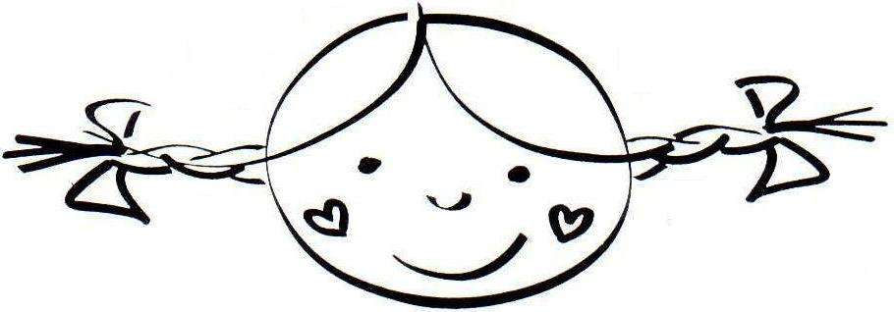
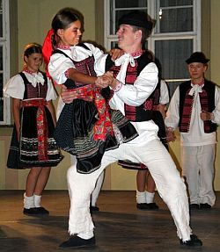
特倫欽(大約有60000位居民)位在斯洛伐克西部瓦赫河(Vah river)中游，向外延伸出廣大的商業區，同時也是重要的交通樞紐，附近就是往捷克共和國的邊界。現在這座充滿中世紀城堡的歷史小鎮已隨著時間轉變成現代工業城市了。
團隊名稱取自附近一座村莊—Soblahov的方言中對女孩麻花辮的稱呼。
目前團隊中有超過100位6~18歲來自特倫欽及其附近的孩子，有跳舞及歌唱分部，使用的樂器有小提琴（violins）、揚琴（cimbalom）、笛子（flute）、中提琴 （viola）、低音提琴（double bass）、以及風琴（bagpipe）。團隊每週在特倫欽練習兩次，而徵選會於每年九月舉行。

表演節目表
KORNIČKA團隊的表演節目靈感吸取自特倫欽(Trenčín)地區以及米亞瓦(Myjava)地區的民俗傳統。表演節目表包括：傳統舞蹈、兒童表演（雙人舞和兒童遊戲）以及音樂與歌曲（男女歌曲、傳統歌曲、耶誕節歌曲……等）

音樂及歌曲節目表
歌名 | 歌曲類型 | 地區
Poruba melodies | Traditional music | Horna Poruba
Bag pipe´s melodies | Traditional music | Kykula-Bosacky
Hrozenske melodies | Traditional music | Chocholna-Kykula
Around Kykula | girl´s traditional songs | Chocholna-Kykula
Welcome Spring | girl´s traditional spring songs | Zablatie
When we´ll pass through Trencin | the music number | Trencin
From Myjava hamlets | the music number | Myjava
Before us there is a green marjoram | the music with singing | Dubodiel
Turna Boys | girl´s songs | Trencianska Turna
Dear my .... | girl´s songs | Myjava
Round Omsenie | girl´s songs | Omsenie
One that doesn´t have a boyfriend in Selec | girl´s songs | Selec
When a girl worked off | girl´s songs | Myjava
Kubra valley | solo - recruit songs | Kubra
"George´s songs" | girl´s traditional songs | Kubra
Meadow songs | girl´s meadow songs | Kubra
Vojano | girl´s summer songs | Kubra
Juvenile songs | instrumental number (heligon) | Trencianska Turna
Recruits | recruit songs | Kubra

舞蹈
舞名 | 簡介 | 地區 | 長度
“Huscarers” | dance reconstruction pair dances | Chocholna-Kykula | 6 min.
Kubraners | the dance reconstruction pair dances following the original interprets in the archive recordings (from the years 1948, 1954 and 1970) | Kubra | 4,5 min.
Trenciners | improvisational pair dances | Trencin | 5 min.
Recruits | Recruit children´s plays and pair dances | Soblahov | 14 min.
Which one is the best... | Girls spring dances | Trencin surroundings | 5 min.
Lubinaners | 2 pairs dance Chardash | Lubina | 5 min.
When we depastured... | Pastoral children´s plays and pair dances depasturing livestock | Soblahov | 12 min.
Scarecrow | Spring time dance game about how we made scarecrows at the cornfield | Trencin surroundings | 10 min.
Vrteny Dance | Girl´s spring time dance | Sedlice | 4 min.
Dances from Ostry vrch | Typical pairs dances Lashunk - frish, Chardash and Sellacka from Ostry vrch mountain.  Dances is the reflection of dance festivity in region Trencin. | Soblahov | 6 min.
Forgotten dance - chardash | In the small “out- of-the-way” village Sipkov people forgot how they had danced in their festivities.  From the oldest inhabitants we received “forgotten” information about this boy´s dance Chardash and then we learned it. | Sipkov | 6 min.
Kubra dances | Pair dance Sellacka is the typical oldest dance in Trencin region. There are remeberd a lot of their dance motives in the part of the city Trencin - named Kubra. | Kubra | 6 min.
Susie´s dream | Solo pair dance reflection of girl´s dream how we went for courting in former times. In this dance number are presented the typical pair dances Lashunk - frish, Chardash and Sellacka | Soblahov | 6 min.
Train | In this stylized singing dance game “Little Train” children imitate train and in its rhythm they dance. | Trencin surroundings | 6 min.
Kubra Christmas | Christmas traditional custom | Kubra | 10 min.
Bethlehem Boys | Christmas traditional custom of Bethlehem Boys | Soblahov | 2,5 min.
Maruliena | children´s dance plays of the youngest dancers | Trencin surroundings | 3 min.

影片連結：http://www.youtube.com/watch?v=JxwPdFjxwOg

得獎紀錄
在25年的活動期間，兒童和青年民俗舞蹈團KORNIČKA贏得了許多國內外民俗舞蹈及音樂比賽獎項(國內：Likavka, Povazska Bystrica, Kosice, Rimavska Sobota; Habovka 國外：Latvia: Riga – 2007; the Czech Republic: Straznice CIOFF – 2004; Breclav - 2008)，Kornička是斯洛伐克最佳兒童及青少年民俗團隊競賽中，連續幾年的三冠得主。團隊也會固定參與國內的民俗慶典活動(Vychodna, Detva Myjava, Bratislava; Hrusov, Dubnica nad Vahom 等.)。
獨奏者和聲樂合唱團錄製了5張CD，包含來自特倫欽(Trencin) 與米亞瓦(Myjava )地區的民俗音樂及歌曲，耶誕合集CD “Wishing You Countless Blessings“（許你無限祝福）以及DVD "Three rills"(三條小溪)。團隊每年約有35場演出，到目前累積了約820場演出，範圍包含國內及國外20個國家 (Taiwan, Portugal, Spain, France, Switzerland, Italy, Germany, Luxembourg, Belgium, Finland, Estonia, Latvia, Lithuania, Poland, Hungary, Serbia, Romania, Bulgaria, Austria and the Czech Republic)。

2024 | France | St–Maixent-l´Ecole | International children folklore festival «RIFE»
2024 | The Czech Republic | Frýdek-Místek,  Valasske Klobouky | International folklore festival  Christmas in Wallachia - Christmas Fair
2023 | Austria | Spittal/Drau, Seeboden, Gmünd | International children folklore festival «Seeboden/Carinthia»
2023 | The Czech Republic | Uherske Hradiste, Luhacovice | International children folklore festival «Kunovice Summer»
2022 | The Czech Republic | Roznov pod Radhostem | International folklore festival «Jánošík’s Ducat»
2019 | Bulgaria | Dorkovo | International folklore festival CIOFF
2019 | Hungary | Szekszard | International children´s folklore festival
2018 | Taiwan | Wu-jie, Tai-pei, Luo-dong | Yilan International Children´s Folklore and Folkgame Festival
2017 | Romania | Cluj-Napoca, Turda, Nadlac | International folklore festival «SERBARILE TRANSILVANE»
2017 | The Czech Republic | Stary Hrozenkov | Traditional Fest
2016 | The Czech Republic | Valasske Mezirici, Kelc | International folklore festival «BABÍ LETO»
2016 | France | Boesenbiesen | «Fête de la Tarte flambeé»
2016 | Luxembourg | Troisvierges, Luxembourg City | Concerts
2016 | Belgium | Hasselt,Kuringen, Westerlo, Eeklo | International folklore festival CIOFF
2016 | The Czech Republic | Brno | International folklore meeting  «FOLKLORE WITHOUT BORDERS»
以下清單是我們主要參與過的國際民俗慶典與演奏會：
2015 | The Czech Republic | Roznov pod Radhostem | Christmas Fair
2015 | France | Anost | traditional festival Fête de la Vielle
2015 | Portugal | Torres Novas, Riachos, Moreiras Grandes, Entroncamento, Chaos | Festival Internacional de Folclore Interfolk
2015 | France | Saint-Didier-la-Forêt | Concert
2014 | The Czech Republic | Velke Karlovice, Stary Hrozenkov | International children folklore festival
2014 | Serbia | Kovacica | Concert
2014 | Bulgaria | Sofia, Busmanci, Bistrica | International children folklore festival SOFIA
2013 | Italy | Spoltore, Introdacqua, Penna Sant'Andrea | INCONTRO DI FOLKLORE INTERNAZIONALE di Penna Sant'Andrea
2013 | The Czech Republic | Zlin | Czech-Slovak Children´s Folklore Festival «MAJICEK»
2012 | Switzerland | Islikon | National Day Celebration
2012 | Spain | Irun, Zumaia, Bera | International children folklore festival
2012 | France | Espelette, Cambo-les-Bains, Hendaye | International children folklore festival GAUARGI
2012 | France | Sennecey le Grand | concert
2012 | The Czech Republic | Straznice | International folklore festival CIOFF
2012 | The Czech Republic | Zlin | International children folklore festival
2011 | The Czech Republic | Velke Karlovice | International children folklore festival
2011 | Italy | Oulx | Folklore evening
2011 | Spain | Les Preses, San Gregori | International folklore festival «ESDANSA»
2011 | France | Flumet | Traditional Fest
2011 | The Czech Republic | Stary Hrozenkov | Traditional Fest
2010 | The Czech Republic | Roznov pod Radhostem | Christmas in Wallachia - Christmas Fair
2010 | Serbia | Belgrade, Kovacica | Concerts, KOVACICA OCTOBER FEST
2010 | The Czech Republic | Uherske Hradiste | Wine Feast of Slovacko
2010 | France | Noyon, Coucy, Crisolles, Cuts | International folklore festival
2010 | France | Obermodern | Traditional Fest
2010 | The Czech Republic | Luhacovice | Spring Opening Festival
2010 | The Czech Republic | Valasske Klobouky | Easter concerts
2009 | The Czech Republic | Satov | International folklore music festival
2009 | The Czech Republic | Stary Hrozenkov | Traditional Fest
2009 | Poland | Sierpc, Rypin, Biezun | International folklore festival «KASZTELANIA»
2009 | The Czech Republic | Vlcnov | «VLCNOV RIDE of KINGS»

 | The Czech Republic | Breclav | International children folklore festival
 | Estonia | Orava-PÕLVA, Vastse-Kuuste | International Children´s Folklore Camp
2008 | Finland | Rovaniemi, Meltaus,  Jämijärvi | International folklore festival «JUTAJAISET» CIOFF  International folklore festival «Sata-Häme Soi»
 | The Czech Republic | Frenstat pod Radhostem | International folklore music festival
 | Lithuania | Panavezys | «Round Dance for the World»  International children´s folk dance festival
2007 | The Czech Republic | Roznov pod Radhostem | Revived Bethlehem
2007 | The Czech Republic | Prague | International folklore music festival
2007 | The Czech Republic | Brno | International folklore festival I.O.V.
2007 | Latvia | Riga, Jurmala, Saldus | «PULKA EIMU, PULKA TEKU»  International Children´s and Youth Festival
2007 | Germany | Saarbruecken | International Children´s and Youth Festival
 | The Czech Republic | Valasske Klobouky | Wallachian St. Nicholas Traditional Folk Market
 | Belgium | Hasselt-Kuringen, Tongeren | International folklore festival CIOFF
2006 | The Czech Republic | Veselí nad Moravou, Buchlovice | «ŠTĚPY»  International children´s folklore festival
 | Italy | Agrigento | «Children of the world»  International children folklore festival
2005 | The Czech Republic | Liptal | «Liptal Feast»  International folklore festival I.O.V.
2005 | The Czech Republic | Stary Hrozenkov | Traditional Fest
2005 | The Czech Republic | Bystrice pod Hostynem | International folklore festival «At the Bystrica Fair»
2005 | The Czech Republic | Lipnik nad Becvou | International folklore festival «Zahori Feast»
2005 | Hungary | Debrecen, Nyiradony | «SZOMSZÉDOLÁS»  International children´s folklore festival
2004 | The Czech Republic | Roznov pod Radhostem | Revived Bethlehem
2004 | The Czech Republic | Luhacovice | «With The Song And Dance»  International folklore festival CIOFF
2004 | The Czech Republic | Brno | International folklore festival I.O.V.
2004 | The Czech Republic | Pisek | International folklore festival
2004 | Hungary | Győr | International folklore festival
2004 | The Czech Republic | Straznice | International folklore festival CIOFF
2002 | France | Caen, Argentan, Lisieux, Colombelle, Dives sur Mer | «Discovery of Slovakia»  The week of slovak culture in Normandy
2000 | The Czech Republic | Stary Hrozenkov | Traditional Fest
在我們的網站可以找到更多團隊資訊及照片：www.kornicka.sk
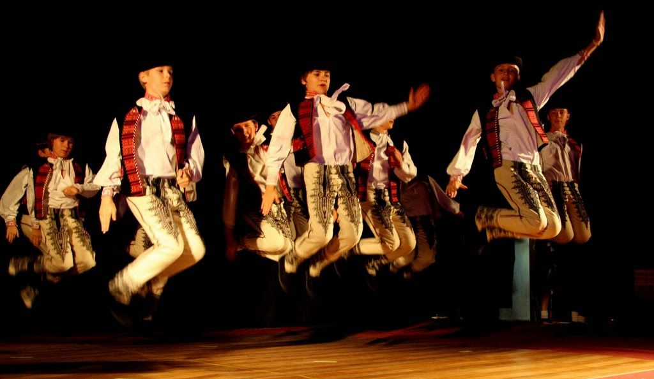

表演提供
從舞蹈到歌曲，我們團隊可以提供您多樣化的節目因應不同類型的活動，像是演奏會、慶典、歡迎會、開幕式、展覽、重要慶祝活動……等
曲目或舞蹈的長度以及數量都可以依照主辦單位的要求調整－從10分鐘至90分鐘。
我們也提供音樂演奏（聲樂合唱團和獨奏獨唱），表演長度20分鐘-40分鐘。
我們非常期待與您合作
並且相信您能夠從我們提供豐富的表演節目中做挑選
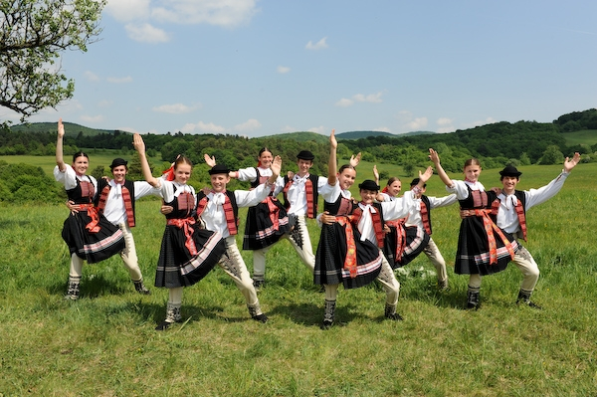

領導團隊
團長 | Kohutova Jaroslava, Boran Vladimir (responsible for abroad tours)
編舞家 | Misik Vladimir
音樂總監 | Boran Vladimir
聲樂指導 | Kohutova Jaroslava
舞蹈總監 | Jurkova Lucia, Gavendova Renata
特別感謝 | Petrovicova Dana

